**Partial differentiation**

**Introduction:** In this section we concentrate on the mathematical term partial differentiation, so to understand this term we should have a knowledge about function of several variables. Now I am trying to clear the term function of several variables by choosing the term volume of a cylinder.

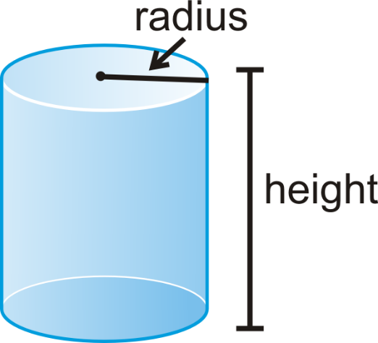

Volume of a Cylinder is  where r is the radius of the Cylinder and h is the height of the Cylinder. We observe that if r changes then no change of h in the above figure besides of this if h changes then no change of r in the above figure. That means r and h are independent variables in. So we call  is a function of two independent variables r and h it means V is a function of several variables.

**Function of Several variables:** A function that contains more than one independent variables is called several variables function. For example  is a function of three variables x, y and z.

**Partial Differentiation:** The differentiation of a function , with respect to *x* **,** treating*y* as constant, is called the partial derivative of *u* with respect to *x*, and it is denoted as,



**Analytically**, 

when this limit exists.

Similarly, the differentiation of a function , with respect to *y* **,** treating*x* as constant, is called the partial derivative of *u* with respect to *y*, and it is denoted as, 

**Analytically**, 

provided this limit exists.

**Successive Partial Derivatives:** Consider a function , which has the partial derivatives with respect to the independent variables *x* and *y* respectively. Also each of them may possess partial derivatives with respect to these two independent variables, and these are called the second order partial derivatives of *u*, and these are denoted as,

.

Similarly, the third order partial derivatives of *u* are denoted as,

.

and so on for higher order derivatives.

**Geometrical Meaning:**

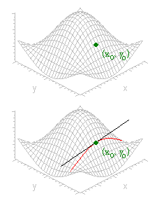

Suppose the graph of z =*f*(*x*, *y*) is the surface shown in the above mentioned figure. Consider the partial derivative of z =*f*(*x*, *y*) with respect to x at a point $\left(x_{0} ,y_{0}\right)$.Holding y as constant and varying x we trace out a curve that intersection of the surface with vertical plane.

The partial derivative measures the change in z per unit increase in x along this curve. That is, is just the slope of the curve at.The geometrical interpretationis analogous. That is  means slope of tangent with x-axis of the function z=*f*(*x*, *y*) at the point (x, y, z) and  means slope of tangent with y-axis of the function z=*f*(*x*, *y*) at the point (x, y, z).

**Symmetric Function:** A function  is called a symmetric function if it satisfies the condition .

**Example:**  is a symmetric function.

**Problem-01:** .



Differentiating (1) partially with respect to *x* we get,







Now differentiating (2) partially with respect to *x* we get,





 **(Ans.)**

Again Differentiating (1) partially with respect to *y* we get,







Now differentiating (3) partially with respect to *y* we get,





 **(Ans.)**

Again Differentiating (3) partially with respect to *x* we get,





 **(Ans.)**

Again Differentiating (2) partially with respect to *y* we get,





 **(Ans.)**

**Problem-02:** 



Differentiating (1) partially with respect to *x* we get,





Now differentiating (2) partially with respect to *x* we get,



 **(Ans.)**

Again Differentiating (1) partially with respect to *y* we get,







Now differentiating (3) partially with respect to *y* we get,





 **(Ans.)**

**Problem-03:** Also show that 



Differentiating (1) partially with respect to *x* we get,









Now differentiating (2) partially with respect to *x* we get,





  **(Ans.)**

Again Differentiating (1) partially with respect to *y* we get,









Now differentiating (4) partially with respect to *y* we get,







 **(Ans.)**

Finally, adding (3) and (5) we get,





 **(Showed).**

**Problem-04:** .



Differentiating (1) partially with respect to *x* we get,









Now differentiating (2) partially with respect to *x* we get,





 **(Ans.)**

Again Differentiating (1) partially with respect to *y* we get,









Now differentiating (3) partially with respect to *y* we get,





 **(Ans.)**

Again Differentiating (2) partially with respect to *y* we get,







 **(Ans.)**

**Problem-05:**



Differentiating (1) partially with respect to *x* we get,









Since the given function (1) is a symmetric function, so similarly differentiating (1) with respect to *y* and *z* we get,



and 

Finally adding (2), (3) and (4) we get,





 **(Showed.)**

**Problem-06:**



Differentiating (1) partially with respect to *x* we get,











Since the given function (1) is a symmetric function, so similarly differentiating (1) with respect to *y* and *z* we get,



and 

Finally adding (2), (3) and (4) we get,







 **(Showed.)**

**Problem-07:**



Differentiating (1) partially with respect to *x* we get,







 

Again Differentiating (2) partially with respect to *x* we get,













Since the given function (1) is a symmetric function, so similarly differentiating (1) with respect to *y* and *z* we get,



and 

Finally adding (3), (4) and (5) we get,









 **(Showed.)**

**Exercise:**

**Problem-01:** .

**Problem-02:** .

**Problem-03:** .

**Problem-04:**

**Problem-05:**

**Problem-06:**

**Problem-07:**

**Problem-08:**

**Homogeneous function:** A function  is said to be homogeneous of degree *n* in the variables *x* and *y* if it can be expressed in the form .

Alternatively, a function  is said to be homogeneous of degree *n* in the variables *x* and *y* if for all values of *t*, where *t* is independent of *x* and *y.*

**Example:**  is a homogeneous function of degree .

**Euler’s theorem on Homogeneous functions:** If  be a homogeneous function of *x* and *y* of degree *n*, then

.

**Problem-01:** .









Here,  is a homogeneous function of degree 2.

By Euler’s Theorem we get,









 **(Showed).**

**Problem-02:** .









Here,  is a homogeneous function of degree 1.

By Euler’s Theorem we get,





 **(Showed).**

**Problem-03:** .











Here,  is a homogeneous function of degree 0.

By Euler’s Theorem we get,





 **(Showed).**

**Problem-04:** .











Here,  is a homogeneous function of degree .

By Euler’s Theorem we get,







 **(Showed).**

**Exercise:**

**Problem-01:** .

**Problem-02:** .

**Problem-03:** .

**Problem-04:** .

**Problem-05:** .